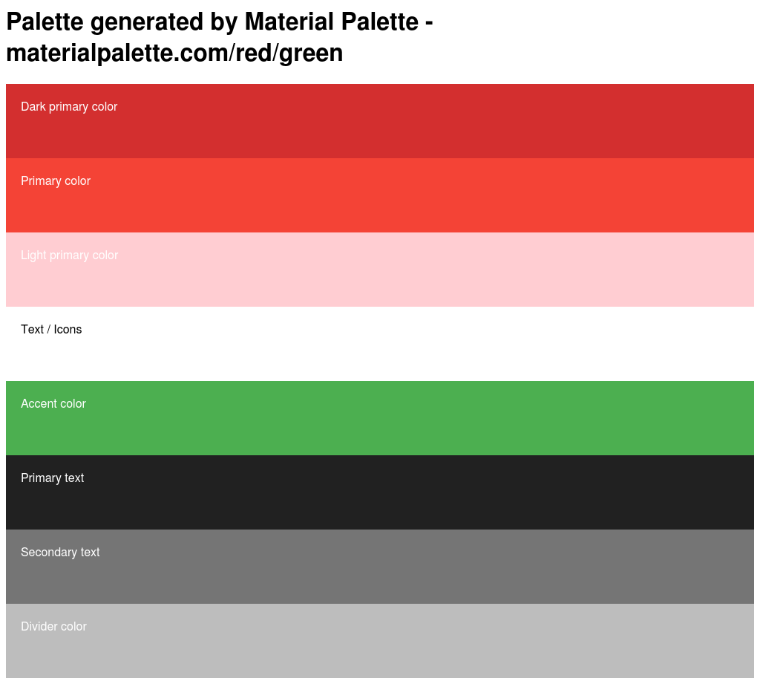
I will probably use RGB, since I understand how that works best.

